People smugglers: saviours or criminals?
A report on 16 convicted people smugglers in Australia between
2001 - 2006



November 2010

Josh Kelly

Report by Australian Lawyers for Human Rights (ALHR)

Suggested Citation

Australian Lawyers for Human Rights (2010) People smugglers: saviours or criminals? A report on 16 convicted people smugglers in Australia between 2001 - 2006

Project Period
August 2010 – November 2010

PREFACE
During the author’s internship with Australian Lawyers for Human Rights (ALHR), Natasha Case – the Secretary of ALHR - suggested that there was a need for an inquiry into whether people smugglers really were the ‘great scourge’ the media and Australian politicians portrayed them to be.

Taking Natasha’s idea as a starting point, the author formulated a design for a research project. With the guidance and support of Linda Tucker – NSW ALHR Co-convenor – and Dr. Chris Ho, at the University of Technology Sydney, the following report came to fruition.

The author would like to thank ALHR, for providing me the opportunity to do an internship, Dr Chris Ho, Dr. Linda Tucker (ALHR NSW Co-convenor), Natasha Case, Stephen Keim SC, and Jonathan Davies for their help in facilitating this project.

All errors remain the author’s own.

INTRODUCTION 1
OUTLINE OF PARTS 1
Australian Lawyers for Human Rights (ALHR) 2
PART ONE: AN INTRODUCTION TO People smuggling 3
What is people smuggling? 3
AUSTRALIAN AND INTERNATIONAL DEFINITIONS COMPARED 9
PART TWO: SOME EXAMPLES OF ‘PEOPLE SMUGGLING’ under Australian law 10
EXAMPLE ONE: MOSES 10
EXAMPLE TWO: OSKAR SCHINDLER 10
EXAMPLE THREE: Bruce Haigh 11
UNINTENDED CONSEQUENCES 12
PART THREE: WHAT CAUSES PEOPLE SMUGGLING? 13
PART FOUR: PEOPLE SMUGGLING IN AUSTRALIA - A CLOSER LOOK 15
PART FIVE: WHO ARE PEOPLE SMUGGLERS? AN ANALYSIS OF 16 Convicted people smugglers in Australia between 2001 - 2006 17
OVERVIEW OF THE RESEARCH 17
RESEARCH METHOD 17
RESULTS: WHO ARE PEOPLE SMUGGLERS? 21
PART SIX: The portrayal of people smugglers in Australia 26
political rhetoric 26
In the media 29
PART SEVEn: CONCLUSION 32
Bibliography 33
Books/ARTICLES/REPORTS 33
AUSTRALIAN LEGISLATION 33
PARLIAMENTARY HANSARDS 34
INTERNATIONAL INSTRUMENTS 34
SUBMISSIONS TO AUSTRALIAN PARLIAMENTARY INQUIRIES 34
World Wide Web 34
Motion Pictures & Audiovisual Material 36
APPENDIX ONE 37
DATA TABLES FOR 16 CONVICTED PEOPLE SMUGGLERS 2001 – 2006 37

INTRODUCTION

With the emergence of the 24 hour news cycle, Australian political debate has been reduced, more than ever before, to a series of catch phrases and oversimplifications. One such example is the slogan ‘stop the boats’. Such techniques fail to communicate the complexity of important issues and tend to create false generalisations in areas of debate that require a more balanced approach.
The title of this report draws on a clear conflict in perceptions of people smugglers: not all people smugglers can be considered saviours, nor can they all be criminals. What is required is a balanced approach that appreciates the individual circumstances of each case.
This report responds to exaggerations and generalisations that surround the debate on people smugglers, by providing guidance through research into 16 convicted people smugglers in Australia between 2001 to 2006, and an analysis of the portrayal of people smugglers in Australian political rhetoric and the Australian media.

OUTLINE OF PARTS
This report contains seven parts.
Part One introduces the reader to ‘people smuggling’, looking at legal and political definitions.
Part Two considers some historical examples of ‘people smuggling’ under Australian law.
Part Three provides an analysis of the causes of people smuggling, for both passengers and smugglers.
Part Four explores the trends in people smuggling in the Australian context.
Part Five contains the main research component of this report: an analysis of 16 convicted people smugglers in Australia between 2001-2006.
Part Six compares the portrayal of people smugglers in the Australian media, and in political rhetoric to the results that were obtained in Part Five.
Part Seven provides some conclusions on the issues surrounding people smugglers in Australia.

Australian Lawyers for Human Rights (ALHR)
ALHR is a human rights advocacy group, with a national membership of over 1,200 people. Through the collective experiences and expertise of its members, ALHR provides a credible and noteworthy voice in Australian human rights debates.

What are the aims of ALHR?
ALHR aims to promote the practice of human rights law in Australia and to increase awareness of significant human rights law issues.

How does ALHR achieve these aims?
ALHR achieves its aims by providing training for lawyers, networking with the Australian legal community, involvement with government consultations, and involvement with the media.

  - Providing training for lawyers: ALHR regularly runs seminars for lawyers on the use of international human rights standards in everyday legal practice.

  - Networking: ALHR is a member of several national human rights law bodies. These include the Australian Forum of Human Rights Organisations, the Commonwealth Attorney General’s NGO Forum on Human Rights, and the Department of Foreign Affairs Human Rights NGO Consultations.

  - Working with Government: ALHR prepares submissions for Senate Committee consultations on Bills which impact upon the Government’s ability to uphold international human rights standards in Australia. ALHR is also frequently called to give evidence before Senate Inquiries.

  - Involvement with the media: ALHR uses the media as an avenue for advocacy by preparing media releases, and by providing contributions to various media outlets.

More information about ALHR is available via their website: http://www.alhr.asn.au/

PART ONE: AN INTRODUCTION TO People smuggling

What is people smuggling?
There is an inherent difficulty in defining the term ‘people smuggling’ given its frequent misuse and abuse.
Years of cynical usage of the phrase in the media and by politicians has led to the phrase taking on a sinister meaning. That is, people smuggling is a crime, carried out by men who exploit people who are often at the lowest point of their lives, charging them thousands of dollars to cross oceans on leaky boats and arrive at countries like Australia in the hope they will find a better life.
Consequently, the only certainty one can have, when it comes to the generally understood definition of people smuggling, is that the average person associates ‘people smuggling’ with a crime. That’s an association that occurs regardless of whatever the complete definition of people smuggling might actually be.
Part One of this report questions the negative and sinister meaning associated with people smuggling by demonstrating that the issue is not so black and white. Before attempting to clear up the confusion that surrounds people smuggling, however, it is necessary to provide a brief set of definitions for some of the terms that are used throughout this report: refugees, asylum-seekers and internally displaced persons. The relevance of these groups is that they define the people that are usually being ‘smuggled’. Following these definitions, this part of the report then explores the definition of people smuggling under international law, and in Australian law and policy.

REFUGEES, ASYLUM-SEEKERS & InTERNALLY DISPLACED PERSONS

WHO ARE refugeeS?
The definition of a refugee at international law can be found in Article 1 of the 1951 Convention Relating to the Status of Refugees. That defines a refugee as someone fulfilling the following five elements:
- a person outside their country of origin;
- who has fled for fear of persecution;
- with a fear that is well-founded;
- where the persecution they fear results from one or more of the 5 grounds in the definition: including race, religion, nationality, membership of a particular social group, or political opinion; and
- is unable or unwilling to seek the protection of their country.

WHO ARE ASYLUM-SEEKERS?
An asylum seeker is defined by the United Nations High Commission for Refugees (2006) as: ‘an individual who is seeking international protection…someone whose claim has not yet been finally decided on by the country in which he or she submitted it. Not every asylum seeker will ultimately be recognised as a refugee, but every refugee is initially an asylum seeker.’
Asylum-seekers are not ‘illegal immigrants’. Asylum seekers only differ from refugees because asylum seekers have left their country of origin and are awaiting recognition as refugees from another country, via a decision on their application. It is not uncommon, however, for the term ‘asylum-seeker’ to be used pejoratively (Parry & Grant, 2004).

INTERNALLY DISPLACED PERSONS
Internally displaced persons (IDPs) include people or groups of individuals who have been forced to leave their homes or places of habitual residence, as a result of, or to avoid the effects of:
- armed conflict,
- situations of generalized violence,
- violations of human rights
- or natural/human made disasters.

IDPs have not crossed an international border, hence the phrase ‘internal displacement’. International law provides protection for IDPs under the Guiding Principles on Internal Displacement (1998).

‘PEOPLE SMUGGLING’: UNDER INTERNATIONAL LAW
The international legal definition of ‘people smuggling’ can be found in Article 3(a) of the ‘Smuggling of Migrants Protocol’ to the United Nations Convention against Transnational Organized Crime (‘UNTOC’) (2004). Australia ratified the UNTOC on 27 May 2004, and the ‘Smuggling of Migrants Protocol’ on 14 September 2005.
Protocol against the Smuggling of Migrants by Land, Sea and Air, supplementing the United Nations Convention against Transnational Organized Crime
Article 3(a):
‘Smuggling of migrants’ shall mean the procurement in order to obtain, directly or indirectly, a financial or other material benefit, of the illegal entry of a person into a State Party of which the person is not a national or permanent resident.

Under that definition, for conduct to satisfy the definition of people smuggling it must include the following elements (UNODC 2010, p.4):
- The procurement of the illegal entry
- Of a person into a state party of which the person is not a national
- In order to obtain, directly or indirectly, a financial or other material benefit.
It is important to note that Article 5 of the ‘Smuggling of Migrants Protocol’ expressly prohibits criminal prosecution of the migrants being ‘smuggled’. Another important feature of this definition is that, under international law ‘people smuggling’ is distinct from human trafficking (UNODC 2010, p.6-7; AIC 2008, p. 2).
The differences between people smuggling and human trafficking are:
- The issue of consent: In people smuggling, the person being smuggled generally consents to illegally crossing a border. Conversely, human trafficking involves the transporting of persons who have not consented to cross a border illegally.
- Conduct upon arrival at the destination: Upon arrival at the destination, smuggled persons will generally be left to make their own way after crossing the border, sometimes with the assistance of fraudulent documents. In human trafficking, the victim being transported is generally given a ‘minder’ to ensure their arrival at the destination. Victims of human trafficking are usually also provided with housing and employment, the latter of which is likely to be in prostitution or forced labour.
- Use of violence: In people smuggling, violence is rarely required. Human trafficking, however, frequently involves the use of threats and violence to recruit and control trafficked victims during a journey.
Although Article 6 of the ‘Smuggling of Migrants Protocol’ requires all member states to criminalise the activity described in Article 3(a), the Protocol is not meant to change international law in respect of refugees. Article 19 provides:
Protocol against the Smuggling of Migrants by Land, Sea and Air, supplementing the United Nations Convention against Transnational Organized Crime
Article 19. Saving clause
- Nothing in this Protocol shall affect the other rights, obligations and responsibilities of States and individuals under international law, including international humanitarian law and international human rights law and, in particular, where applicable, the 1951 Convention and the 1967 Protocol relating to the Status of Refugees and the principle of non-refoulement as contained therein.

This ‘saving clause’ is crucial because refugees and asylum-seekers frequently rely on people smugglers. As a consequence, the following articles (as well as others) within the 1951 Convention relating to the Status of Refugees are not affected:
Australia has accepted, but not ratified, the Refugee Convention and its Protocol.
Convention and Protocol relating to the Status of Refugees
Article 31. Refugees unlawfully in the country of refugee
1. The Contracting States shall not impose penalties, on account of their illegal entry or presence, on refugees who, coming directly from a territory where their life or freedom was threatened in the sense of article 1, enter or are present in their territory without authorization, provided they present themselves without delay to the authorities and show good cause for their illegal entry or presence.
2. The Contracting States shall not apply to the movements of such refugees restrictions other than those which are necessary and such restrictions shall only be applied until their status in the country is regularized or they obtain admission into another country. The Contracting States shall allow such refugees a reasonable period and all the necessary facilities to obtain admission into another country.

Convention and Protocol relating to the Status of Refugees
Article 33 Prohibition of expulsion or return (“refoulement”)
1. No Contracting State shall expel or return (“refouler”) a refugee in any manner whatsoever to the frontiers of territories where his life or freedom would be threatened on account of his race, religion, nationality, membership of a particular social group or political opinion.
2. The benefit of the present provision may not, however, be claimed by a refugee whom there are reasonable grounds for regarding as a danger to the security of the country in which he is, or who, having been convicted by a final judgment of a particularly serious crime, constitutes a danger to the
community of that country.

‘PEOPLE SMUGGLING’: IN AUSTRALIAN LAW AND POLICY

AUSTRALIAN LAW
For the definition of ‘people smuggling’ under Australian law, the starting point is Division 12, Subdivision A of the Migration Act 1958 (Cth). That subdivision in its current form, is titled ‘People Smuggling and related offences’ and contains 16 sections that define when a person will be engaged in people smuggling, and how they should be sentenced. In the context of this report, the three most important sections are the current definition of ‘people smuggling’ in section 233A; section 232A (for all ‘people smuggling offences’ before-1 June 2010); and section 233(1)(a) (for all ‘people smuggling offences’ before 9 July 2001).
Migration Act 1958 (Cth)
Section 233A Offence of people smuggling
1) A person (the first person ) commits an offence if:
(a) the first person organises or facilitates the bringing or coming to Australia, or the entry or proposed entry into Australia, of another person (the second person ); and
(b) the second person is a non-citizen; and
(c) the second person had, or has, no lawful right to come to Australia.

Penalty: Imprisonment for 10 years or 1,000 penalty units, or
both.

Section 232A Organising bringing groups of non-citizens into Australia:
1) A person who:
(a) organises or facilitates the bringing or coming to Australia, or the entry or proposed entry into Australia, of a group of 5 or more people to whom subsection 42(1) applies; and
(b) does so reckless as to whether the people had, or have, a lawful right to come to Australia;
is guilty of an offence punishable, on conviction, by imprisonment for 20 years or 2,000 penalty units, or both.

233 Persons concerned in bringing non-citizens into Australia in contravention of this Act or harbouring illegal entrants
- A person shall not take any part in:
  - the bringing or coming to Australia of a non-citizen under circumstances from which it might reasonably have been inferred that the non-citizen intended

Penalty: Imprisonment for 10 years or 1,000 penalty units,
or both.

These provisions are applied almost exclusively to instances of people smuggling by boat.

One of the reasons there have been three definitions of ‘people smuggling’ under Australian law over the past 10 years is that successive Australian Parliaments have amended the definition of ‘people smuggling’ in the hope that a tougher stance would provide a more effective deterrent to people smugglers across the globe. Importantly, Division 73 of the Commonwealth Criminal Code repeats the definitions above, making a breach of ss 233A, 232A or 233(1)(a) a criminal offence against the Commonwealth of Australia.

AUSTRALIAN POLICY and POLICY STATEMENTS
‘People smuggling refers to the organised illegal movement of groups or individuals across international borders, usually on a payment for service basis’
Department of Immigration and Multicultural and Indigenous Affairs (DIMIA) (2005)

Under this bill people acting on humanitarian grounds, or offering financial support to refugees overseas, can be charged with people-smuggling offences. This bill treats good Samaritans the same as ‘for profit’ people smugglers, which means that under this bill the nuns from The Sound of Music could be thrown into jail. That is one of the unintended consequences of this bill. That is plainly ridiculous.
Senator Nick Xenophon, Second Reading Speech Anti-People Smuggling and Other Measures Bill 2010
Thursday 13 May 2010

This bill will expand the crime of people smuggling to include those people who provide material support or resources towards a people smuggling venture. It also contains provisions which harmonise the people-smuggling offences contained in the Criminal Code and the Migration Act, making it easier for us to prosecute people smugglers when they break our laws. People smugglers have no respect for our laws. They endanger the lives of vulnerable people and they threaten the border integrity of this country.
Senator Steven Fielding, Second Reading Speech Anti-People Smuggling and Other Measures Bill 2010
Thursday 13 May 2010

These definitions of ‘people smuggling’ are at odds with the definitions used in Australian and international law.

AUSTRALIAN AND INTERNATIONAL DEFINITIONS COMPARED
INTERNATIONAL DEFINITION | AUSTRALIAN LEGAL DEFINITION | AUSTRALIAN POLICY DEFINITION (DIMIA)
Subject to the Refugee Convention and its Protocol:  - The procurement of the illegal entry  - Of a person into a state party of which the person is not a national  - In order to obtain, directly or indirectly, a financial or other material benefit. | Without being subject to the Refugee Convention and its Protocol:  1) the first person organises or facilitates the bringing or coming to Australia, or the entry or proposed entry into Australia, of another person (the second person ); and  2) the second person is a non-citizen; and  3) the second person had, or has, no lawful right to come to Australia. | Without being subject to the Refugee Convention and its Protocol:  1) The organised illegal movement of groups or individuals  2) across international borders,  3) usually on a payment for service basis
What becomes apparent upon a comparison of these definitions is that Australian law omits the requirement that the people smuggling should occur in order for the ‘smuggler’ to obtain a financial or other material benefit. Moreover, both of the Australian definitions (in law and policy) are not subject to the Refugee Convention and its Protocol.
It is questionable whether Australia’s ‘unique’ border protection problems provide sufficient grounds for not following the international legal definition. The international definition represents a consensus reached by more than 150 nation-states. Further, the requirement of financial/material benefit in the UNTOC definition does not make it impossible to prosecute people smugglers who enter Australia’s borders.

PART TWO: SOME EXAMPLES OF ‘PEOPLE SMUGGLING’ under Australian law
Senator Xenophon’s statement above, that s 233A of the Migration Act 1958(Cth) would make the nuns in the Sound of Music ‘people smugglers’ raises an interesting question. What other historical examples of assistance to refugees would be considered people smuggling under s 233A of the Migration Act 1958 (Cth)? This part of the report adopts the current Australian legal definition of people smuggling, and applies that definition to a series of historical instances where assistance has been provided to refugees: Moses, Oskar Schindler, and former Australian diplomat Bruce Haigh.
This is done solely to provide a critical analysis of the Australian legal definition of ‘people smuggling’. No disrespect towards the examples being cited is intended. Moreover, the author recognises that the historical examples used below may have personal, religious or cultural significance for some readers.

EXAMPLE ONE: MOSES
The story of Moses is contained in both the Hebrew and Christian Bibles. Before Moses received the Ten Commandments, he was charged with leading the exodus of the Hebrew people, out of Egypt and across the Red Sea, to the base of Mount Sinai.
If one were to change Mount Sinai to Australia, would this conduct have amounted to the offence of people smuggling under s 233A? The answer is yes. Moses’ conduct would have satisfied the legal requirements of:
- an organisation of the coming to Australia;
- of an entire people who were not Australian citizens; and
- who would not, under Australian law, have a lawful right to come to Australia.
Under international law, however, Moses’ actions would not be ‘people smuggling’ because Moses did not make any direct or indirect financial/material benefit from the exodus.

EXAMPLE TWO: OSKAR SCHINDLER
Oskar Schindler is often credited as the German who saved more Jews from persecution than any other single person during World War II. Using Jews as forced labourers in his enamelware and ammunition factories, Schindler is responsible for having saved 1,200 Jewish lives. Schindler achieved this remarkable feat by moving the whole of his factory and his Jewish workers from Plaszow, Poland – where they were facing certain death – to Brunnlitz, in the then occupied Czechoslovakia.
In a similar manner to the example above, if one were to change Brunnlitz, Czechoslovakia to Port Hedland, Australia, would this conduct have amounted to the offence of people smuggling under s 233A? Again, the only answer to that question is yes. Schindler’s conduct would have satisfied the legal requirements of:
- an organisation or facilitation of the coming to Australia;
- of 1200 people who were not Australian citizens; and
- who would not, under Australian law, have a lawful right to come to Australia.
Again, however, Schindler’s actions would not be ‘people smuggling’ under international law because he did not make any direct or indirect financial/material benefit from his actions. In fact, the historical evidence of Schindler’s operations suggests he lost money because of his involvement in people smuggling (Crowe, 2007).

EXAMPLE THREE: Bruce Haigh
The final example is Bruce Haigh, an Australian diplomat in South Africa between 1976 and 1979. Confronted by a ruthless police state enforcing apartheid, Haigh assisted numerous black South Africans in leaving South Africa. But for Haigh’s efforts, those black South Africans might have faced imprisonment, torture or even murder. Unfortunately, however, if Haigh had taken those South Africans to Australia, he would have been guilty of ‘people smuggling’ under s 233A, because he had been involved in:
- the organisation of the coming to Australia;
- of at least five people who were not Australian citizens; and
- who would not, under Australian law, have had a lawful right to come to Australia.
Again, Haigh would not be a people smuggler under international law, because he smuggled his ‘passengers’ out of South Africa solely out of an altruistic concern for their safety. (Haigh, 2007)

UNINTENDED CONSEQUENCES
If the effect of s 233A is to criminalise the actions of Moses, Oskar Schindler and Bruce Haigh, something is wrong with Australia’s law in this area. Conducting a similar analysis of Australia’s definition of people smuggling, Australian writer Bob Ellis remarked in 2009 that:
[People smugglers] are making an enormous sacrifice I think, and they're probably good people, heroes even. They're making as big a sacrifice, pretty much, as the Australian soldiers we're sending off soon to battle the Taliban in a war Obama says we're losing.
Or am I wrong? Am I wrong to suggest this might be so?
What other explanation is there?
That they risk their own and other people's lives for the fun of it? That they hope to swim home? That they, too, were duped by the 'travel agents' who are laughing all the way to the bank? That the money goes to their families while they go to jail?
Some of us are divided on this question. Some of us think the French Maquis, and the Dutch and Swedish secret agents who spirited shot-down airmen out of the Third Reich were 'the scum of the earth'.
And some of us don't.
Including, I suspect, the Afghan people whose boat sank and who ended up on the Tampa, 400 or so of whom are living as free Australians in this good country now. I suspect, though they dare not admit it, they're grateful to their saviours for their present happy lives.
Are their saviours in jail? Should they be? Can evil men do good? Can scum do the work of our better angels? Should they rot in hell anyway?
Australia’s current legal definition of people smuggling categorises a large number of people, who have helped refugees, as criminals, even though, on any normative scale, those people would be considered saviours.

PART THREE: WHAT CAUSES PEOPLE SMUGGLING?

For the passengers
The primary reason people use people smuggling services, via boats, is because of an inability to migrate via standard transport services, such as planes, coach lines, cruise boats, and trains. That inability to travel via standard transport services most frequently occurs where a person is fleeing persecution and consequently has a need for covert travel. It also occurs where people fleeing persecution have lost their travel documents, or had their travel documents destroyed (Smit 2009).
Particularly in the context of refugees, as the UNHCR(2010) has observed:

Refugees run away. They often do not know where they will end up. Refugees rarely have the chance to make plans for their departure such as packing their personal belongings or saying farewell to loved ones. Many refugees have experienced severe trauma or have been tortured.

For these reasons, as well as others, refugees will frequently turn to people smugglers to obtain quick and covert entry into countries like Australia.
People smuggling may also be used because a person is unable to travel by standard transport services due to a significant criminal history. People smuggling services on boats thus provide a covert means of travel that will often enable such persons to avoid detection. These alternative motives throw up the complexity of regulating and prosecuting people smuggling.

for the smugglers
As the research in Part Five of this report indicates, there are three primary motivations for people smugglers to become involved in the ‘people smuggling’ trade:

- Financial need: Many people smugglers, particularly fishermen, become involved in people smuggling because it offers a high rate of pay, at least 10 times above their weekly wage. People smugglers motivated by financial need always come from low socio-economic backgrounds. As Australia has toughened fishing regulations for the oceans in our Exclusive Economic Zone over the past decade, fishermen from countries such as Indonesia have turned to alternative means of obtaining income, such as people smuggling (Hunyor 2001, p.226; Balint 1999).

- Profit: Other people smugglers, often at the level of senior organisers, will be motivated by the potential that a people smuggling operation has to make a profit, at the expense of their passengers’ safety and welfare. While this is the widely recognised ‘evil’ motivation, there is still an inherent difficulty in identifying when a people smuggler is motivated solely by profit or by another motivation.

- Altruistic concern: Some people smugglers will be motivated by an altruistic concern for the safety of their passengers. Frequently, these people smugglers make little or no profit from their operations. There seems little reason to criminalise this conduct, but currently Australian law makes no exception for those people smugglers who are acting out of an altruistic concern.

PART FOUR: PEOPLE SMUGGLING IN AUSTRALIA - A CLOSER LOOK
Applying the definition of people smuggling under Australian law, and limiting it to the context of people smuggling by boats, how frequently does people smuggling occur in Australia?
Surprisingly, as the data below shows, between 1989 and 2010 there was no clear trend in the incidence of people smuggling, by boat, to Australia. Politicians may encourage the public to attribute levels of arrivals like the decrease between 2002 to 2006 to the variety of enforcement and detection methods that were used during that period. Yet it is clear is that, any attempt to ‘stop the boats’ (if that’s what we really want) will be more complex than many politicians would have the Australian population believe.

Year | Number of boats | Number of people
1989 | 1 | 26
1990 | 2 | 198
1991 | 6 | 214
1992 | 6 | 216
1993 | 3 | 81
1994 | 18 | 953
1995 | 7 | 237
1996 | 19 | 660
1997 | 11 | 339
1998 | 17 | 200
1999 | 86 | 3721
2000 | 51 | 2939
2001 | 43 | 5516
2002 | 1 | 1
2003 | 1 | 53
2004 | 1 | 15
2005 | 4 | 11
2006 | 6 | 60
2007 | 5 | 148
2008 | 7 | 161
2009 | 61 | 2849
.

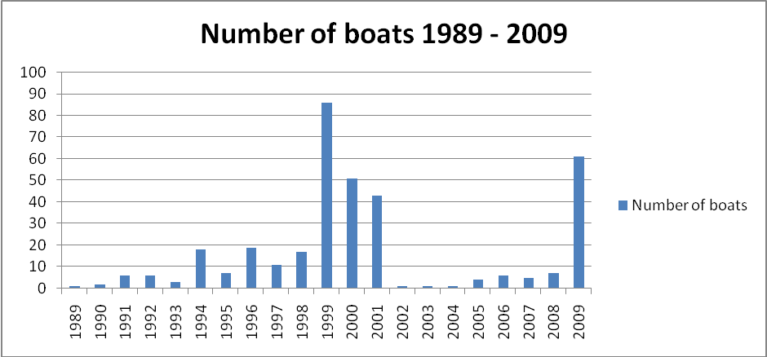

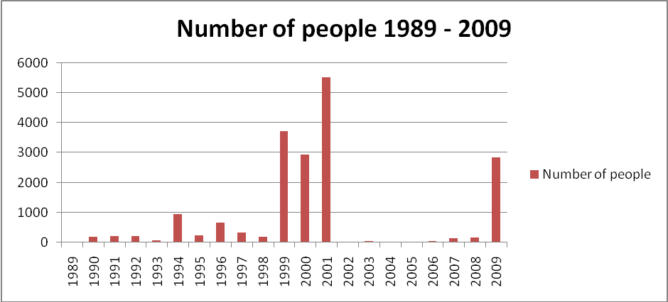

Data sourced from Phillips, J. & Spinks, H. 2010 ‘Boat arrivals in Australia since 1976: Background Note’ Parliament of Australia: Parliamentary Library available at http://www.aph.gov.au/library/pubs/bn/sp/boatarrivals.htm

PART FIVE: WHO ARE PEOPLE SMUGGLERS? AN ANALYSIS OF 16 Convicted people smugglers in Australia between 2001 - 2006

In light of the research above, the question arises: who are people smugglers? Are they saviours, or are they criminals? Or are they neither? This part of the report responds to that question.

OVERVIEW OF THE RESEARCH
To answer the question, ‘who are people smugglers?’ research was conducted on 16 convicted people smugglers between 2001 and 2006. For each people smuggler, a ‘profile’ was compiled, taking into account a number of different characteristics. The data gained from those profiles was then analysed.

RESEARCH METHOD
The following criteria were used to select the 16 people smugglers considered in this report:
- a conviction under either s 233(1)(a) or s 232A of the Migration Act 1958 (Cth);
- between 2001 – 2006; and
- sufficient information on their personal circumstances was available.
All the people smugglers that were researched had been convicted for smuggling people into Australia by boat.
The two courts that convict the majority of people smugglers in Australia are the District Court of Western Australia and the Northern Territory Supreme Court. As trial judgments and sentencing remarks from those courts are not available electronically, the only convicted people smugglers that are included in this report are those that had had their judgments heard in appellate courts, or those that had received widespread media coverage. Accordingly, the sources used to collect information on people smugglers included: appellate case reports and media reports. The majority of appellate case reports contained excerpts from police interviews, sentencing remarks and trial transcripts.
Data from the Department of Immigration, Multicultural and Indigenous Affairs indicates that between 2001 and 2005, 17 people smugglers were convicted in Australia (DIMIA 2005, p. 95). This research considers 14 out of the 17 people smugglers that were convicted between 2001 to 2005. The two extra people smugglers are taken from 2006.
Each convicted people smuggler was analysed using a ‘profile’. That profile was developed using the following headings:
- Statutory provision charged under
- Date of conviction
- Sentence received
- Age at conviction
- Gender
- Place of origin
- Previous occupation(s)
- Socio-economic background
- Any other personal history
- Level of involvement in the people smuggling operation(s)
- Motivations for involvement
- Details of the people smuggling operation(s)
- Cost charged to passengers
- Date of boats
- How many boats they were allegedly involved with
- Allegedly took how many passengers on the boats
- Refugee status of the passengers

These headings were developed to create a nomothetic analysis of people smugglers: a study of a large group for the purposes of determining the frequency of particular factors (Maxfield, 2004). The data on the 16 people smugglers, collected under these headings, is included in Appendix One.

Notes on particular HEADINGS

Socio-economic background
For the purposes of considering the socio-economic backgrounds of convicted people smugglers, three discrete categories were developed:
- Low: this category describes people smugglers who had both a low level of education, and a poor economic background. This category was the equivalent of the average third-world standard of living.
- Medium: this category describes people smugglers who had either a low level of education and a moderately well-off economic background, or a medium level of education and a humble economic background.
- High: this category describes people smugglers who had a good level of education and financial independence. This category was equivalent to the average standard of living in Australia.

Level of involvement in people smuggling operation(s)
In considering the various levels of involvement of people smugglers, a set of categories was used. These categories draw from a typology developed by Mathias Neske (2006). People smugglers were placed in a particular category according to the findings of fact in courts.
The categories include:
- Crew members: this is the lowest possible level of involvement. It includes convicted people smugglers who were passengers on a ship and had assisted higher level people smugglers, as well as crew members of a ship responsible for duties like repairs and general maintenance.
- Stage co-ordinators: this is the next highest level of involvement and encompasses all ‘middlemen’ as well as those responsible for co-coordinating a particular stage of the journey, for example, captains and owners of vessels.
- Senior organisers: this is the highest level of involvement. To fall within this category, a people smuggler had to have been prosecuted on the basis that they were responsible for the majority of organisational activities in a people smuggling operation.

Motivations for involvement in people smuggling operation(s)
Convicted people smugglers’ motivations for involvement in people smuggling operations are also organised using three categories. These categories were developed relative to the motivations of the people smugglers who were researched. Where a convicted people smuggler was found to have had a mix of motives falling within two or more categories, all relevant categories were indicated as having had an increase in frequency.
The categories include:
- Financial need: this category applied where the convicted person had only agreed to participate in the people smuggling operation out of a financial need.
- Profit only: this category was applied where the convicted person had been involved in the people smuggling operation to make a profit for self-gain, not out of a financial need, but out of a desire to make a commercial profit.
- Altruistic concern: this category was applied where the convicted person had been found to be responsible for organising the trip out of a concern for the welfare of those on board the ship. It included instances where the people smuggler had a concurrent motivation for self-preservation.

RESULTS: WHO ARE PEOPLE SMUGGLERS?

GENERALLY
It is difficult to make broad generalisations in answer to the question ‘who are people smugglers?’. More importantly, such generalisations are apt to mislead and oversimplify a complex area of debate.
Subject to that caveat, a few general conclusions can be reached using the data from the 16 convicted people smugglers that were researched.
Of the 16 people smugglers:
- the average age was 35.5 years at the date of conviction;
- they were all male;
- at least 10 were refugees themselves;
- more than 30% were fishermen before they became involved in people smuggling;
- just under half the people smugglers were married at the time of their conviction;
- at least 3 of the people smugglers had two or more children;
- the average sentence they received was 7 years imprisonment
- all came from a low or humble socio-economic background;
- all came from a country that was previously a zone of conflict or political unrest;
- the majority were senior level organisers;
- the majority were motivated by altruistic concerns, rather than making a profit at the expense of their passengers.

PLACE OF ORIGIN
The 16 convicted people smugglers came from Pakistan, Kuwait, Vietnam, Iraq, Indonesia, Sri Lanka or Turkey. All of these areas have been zones of conflict and are subject to either poor living and working conditions and/or political unrest. The following column graph displays the various places of origin of the 16 people smugglers. As the graph shows, the greatest number came from Sri Lanka.

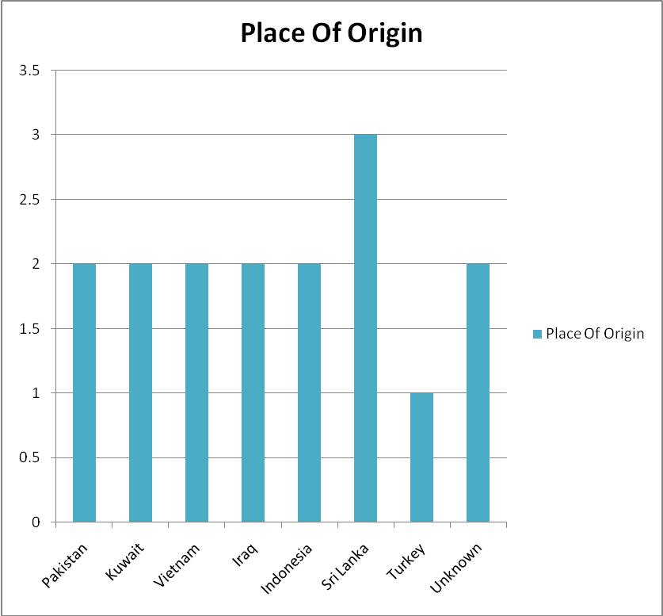

SOCIO-ECONOMIC BACKGROUND
None of the people smugglers was placed in the ‘well-off’ socio-economic background category. As the column graph below shows, the majority were either from the ‘low’ or ‘medium’ categories. Further, there was no evidence that any of the people smugglers had tertiary qualifications.
When the results for socio-economic background are considered in conjunction with the results for ‘place of origin’ (above), there is a real and obvious link between people smuggling and low socio-economic backgrounds, especially in areas that are subject to political unrest, low economic prosperity, or armed conflict.
Interestingly, the convicted people smugglers had a large array of previous occupations. These included:

- Crane operator
- Gun exporter
- Restaurateur
- Silver and goldsmith
- Army commander
- Political activist
- Fisherman
- Mechanic
- Small business owner
- House and land salesperson
- Sharebroker
- Live sheep trade worker
- Second-hand goods salesperson
- Kebab-shop worker

Five of the 16 people smugglers had previously been fishermen. An explanation that has previously been offered for this statistic is that, following heightened regulation of Australia’s fishing laws, many fishermen across Asia have been forced into finding alternative means of income through activities such as people smuggling (Hunyor 2001, p.226; Balint 1999).

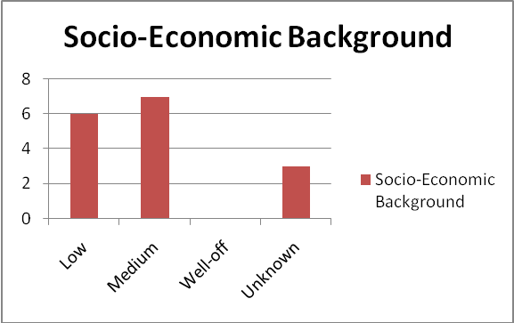

LEVEL OF INVOLVEMENT in people smuggling operation(S)
The majority of people smugglers in the research fell into the ‘senior organiser’ category. There are two possible explanations for this statistic. First, given the source of information (mostly appellate court case reports), it is more likely that the people smugglers who were able to appeal their trial sentences would be at the senior level of organisation, having the financial capacity to pay for the costs associated with an appeal. Alternatively, the over-representation of senior organisers may be attributed to the prosecution policies of the Commonwealth Director of Public Prosecutions and the Australian Federal Police.

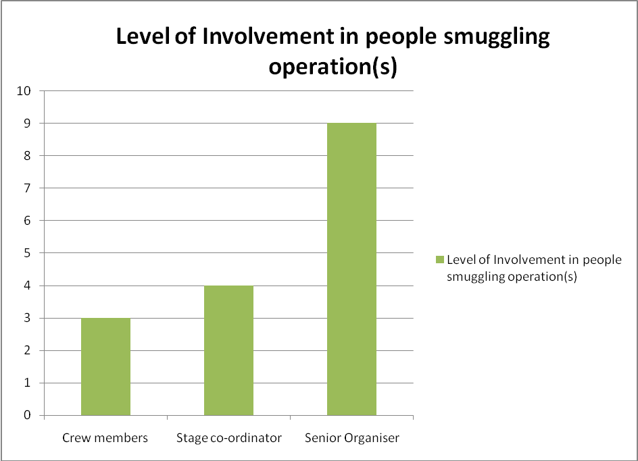

MOTIVATIONS FOR INVOLVEMENT
This statistic is, in some ways, one of the more interesting and revealing statistics that comes out of the research, particularly in light of public debate and coverage of ‘people smugglers’. For the majority of convicted people smugglers, their involvement in the various people smuggling operations was a result of altruistic concern or financial need, rather than a desire to make a profit at the expense of others. These results are reflected in the column graph below.
When one considers that 10 out of the 16 people smugglers are refugees themselves, there is a link between people smugglers who are refugees, and the ‘business’ of people smuggling. One possible explanation for that link is that people smugglers might be the ‘heroes’ Bob Ellis was talking about when he wrote his article for ABC Unleashed in 2009. The research also reveals a link between financial need and people smuggling, given that four out of the 16 people smugglers had financial need as one of their motivations.
While five of the convicted people smugglers were found to be taking advantage of the needs of others to gain a profit for themselves, this research highlights that profit wasn’t the sole motivating factor for the majority of people smugglers and, more often than not, profit wasn’t a motivating factor at all.

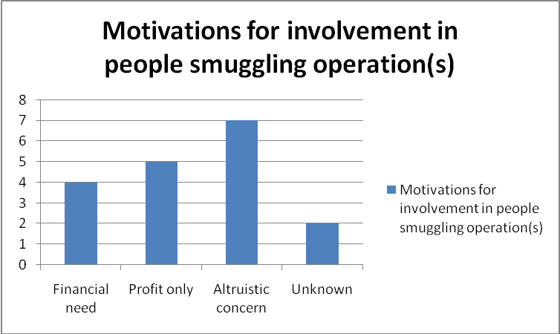

PART SIX: The portrayal of people smugglers in Australia

In light of the above research, is people smuggling correctly portrayed in Australian political rhetoric and by the Australian media? Taking a sample of quotes from Australian media sources and politicians, this part of the report provides examples of the representation of people smugglers in Australian political rhetoric and by the Australian media.

political rhetoric
A suitable starting point for considering the political rhetoric around ‘people smuggling’ is a press release from Kevin Rudd, former Prime Minister of Australia, on 17th April 2009. This statement was made following a people smuggling boat blast that resulted in three deaths and at least 22 casualties:

"People smugglers are engaged in the world's most evil trade and they should all rot in jail because they represent the absolute scum of the earth…People smugglers are the vilest form of human life. They trade on the tragedy of others and that's why they should rot in jail and in my own view, rot in hell. We see this lowest form of human life at work in what we saw on the high seas yesterday. That's why this Government maintains its hardline, tough, targeted approach to maintaining border protection for Australia."

This echoed the earlier comments in Phillip Ruddock’s Second Reading Speech for the Migration Amendment (Excision from Migration Zone) Bill 2001, on 18 September 2001, while he was Minister for Immigration and Multicultural Affairs:

We all know about the dramatic increase over the past few years in the number of unauthorised people who have been arriving in Australia by boat—we read about it every month in our newspapers.
In the late 1970s we had some unauthorised boat arrivals from Vietnam, in the late 1980s some from Cambodia, and in the mid-1990s some from the People's Republic of China.
However, these were comparatively small in numbers, and importantly Australia could have been considered as a country of first asylum for people fleeing some of these countries.
What has changed since then has been the growth of organised criminal gangs of people smugglers who are motivated not by any desire to help others, but by base motives of greed.
This form of organised crime is found throughout the world and preys on people who are unwilling, for whatever reason, to go through normal procedures for entry to the country of destination.

Senator Michaelia Cash used a question without notice on 22 June 2010 to attack both people smugglers and those they bring to Australia:

The major difference between us and those on the other side is that, for the betterment of this country and for the safety of women, children and families who may well seek to put their lives at risk, we believe in a fair and orderly immigration process for those coming to this country. What Mr Rudd again forgets to tell the people of Australia is that for every place that is given to a refugee who has come here unlawfully we have to say to those refugees who have done the right thing, ‘I’m sorry, mate, but someone else who did the wrong thing has taken your place in Australia.’
The coalition is very proud to stand by its commitment to priority being given to those who are offshore and who have done the right thing. Those who are in the United Nations refugee camps do not have US$10,000, US$15,000 or US$20,000 to pay to people smugglers, who, let us recall, Mr Rudd called the vilest form of human life. They do not have that money. They have nothing. They seek to do the right thing when coming to this country. Mr Rudd and the Labor Party are only interested in scoring cheap political points to deflect from their gross failure in border protection. There is no doubt that the boats will keep coming unless we elect a coalition government.

The question by Senator Eric Abetz to Senator Chris Evans on 21 June 2010 also highlighted ‘criminal behaviour’:

I ask a further supplementary question, Mr President. I note the minister’s refusal once again to answer the questions. Does the minister now deny that Labor’s policy is encouraging the criminal behaviour of people smugglers, who are luring these families onto rickety boats, putting children’s lives at risk and, to quote one of the minister’s most senior departmental officials, ‘exposing more people to danger’?

The language of the Opposition’s questions is mirrored by recent statements of the Government. In the Second Reading Speech of the amending bill to the Migration Act 1958 that introduced s 233A on 13 May 2010, Senator Chris Evans states:

People smuggling is exploitive and dangerous. People smugglers are motivated by greed and work in sophisticated cross-border crime networks. They have little regard for the safety and security of those being smuggled, endangering their lives on unseaworthy and overcrowded boats.

These questions and statements can, however, be balanced with the comments made by Senator Andrew Bartlett, of the Australian Democrats, in 2006:

There are other cases where refugee men who arrived on boats seeking asylum were convicted of people smuggling, and despite being assessed as refugees by Australia, DIMIA put up the people smuggling convictions as 'character barriers' as an obstacle for the men being issued with protection visas. Appeals to the AAT (Administrative Appeals Tribunal) by the refugee men were successful and the Department's decisions overturned.
As mentioned above in the Judge's comments in sentencing Mr Tran, Section 233C of the Migration Act, now contains mandatory sentencing provisions which apply in relation to people smuggling offences under Sections 233A and 233B. The mandatory sentencing provisions were contained in amongst the seven pieces of legislation guillotined through the Senate on 26 September, 2001 in the wake of Tampa incident and on the eve of the 2001 federal election.
These provisions were not justified at the time, and became law only due to the heated political climate of the time. Since then, we have the example of Mr Tran and Mr Nguyen being charged for offences when neither were profiteering in any way, and Mr Tran was clearly a bona fide asylum seeker. This has shown that mandatory sentencing provisions can produce patently unjust outcomes.
The Senate should take the opportunity presented by this legislation to repeal the mandatory sentencing provisions contained in Section 233C. For similar reasons, the Senate should not agree to introducing strict liability

Similarly, the excerpt from Senator Xenophon’s second reading speech (see above) should be considered here. Unfortunately, however, a review of the Hansards for both the Commonwealth House of Representatives and the Commonwealth Senate reveals that, at the federal level of Australian government, there is an overwhelming amount of political rhetoric that paints people smugglers in a negative and sinister light.

In the media
The Australian media frequently takes a similar approach, although the spectrum of opinion is much greater. At the lighter end of the spectrum, there is the prose of Bob Ellis:

We're told [people smugglers] risk the refugees' lives in storms and leaky boats, but they risk their own lives too - as well as capture, and arrest, and 25 years in jail.
How can this be 'just doing it for the money'? It sounds pretty heroic to me, pretty selfless, pretty self-sacrificing. Like the border guards who helped the Holy Family flee to Egypt during Herod's massacre of Israel's first born. Or the Kentish fisher-folk who came in little boats to save the British army at Dunkirk, people smugglers whose memory still brings tears to Britons over 50.
…
Has the habit of thinking ceased in our native land? Has it been replaced by soothing babble on mobile phones? Or replaced, perhaps, by Piers and Gerard and Janet and the ailing Alan Jones? Is consecutive thought a 20th Century thing face down in the trash-bin of history now and robot-thinking, like Rudd's on people smuggling, its post-post-modern replacement?
Just asking.

Or the reporting of Jack Smit, who runs Project SafeCom:

Most of the elements of Australia's people smuggling laws, which are the harshest smuggling laws in the world, while in 1999 and 2001 Australia was the first country in the world to establish people smuggling laws, are brazen acts of political screams by politicians, bullying voters with the line 'vote for me, I am tougher on border protection than the other side of politics'….
Australia's smuggling laws have nothing to do with stopping any form of "transnational crime" as they claim, mouthing the United Nations Protocol against the Smuggling of Migrants by Land, Sea and Air (the Smuggling Protocol), especially since we scrapped the UN smuggling definition from our Criminal Code in June this year under new federal anti-smuggling legislation

Smit has also advocated in favour of Australia taking over the people smuggling business, instead of criminalising it (Smit 2010). Although Smit’s proposal raises its own set of issues, it throws up the possibility that perhaps we have not considered all the solutions that exist.

Stephen Keim SC (now president of ALHR), remarked on Kevin Rudd’s comments on people smugglers on 17 April 2009:

The Prime Minister has, no doubt, thought that his comments concerning people smugglers assisted the debate by not focusing the blame on refugees. [But] they have the potential to jeopardise future trials...
The remarks also fail to distinguish between the act of breaking laws against people smuggling and whether or not, in breaking those laws, the person did all they could to protect the safety of the persons from whom they took money.

At the opposite end of the spectrum is Alan Jones of 2GB radio, who commented on his Breakfast Show on 26 March 2010:

The smugglers know the rules. The new ones. They know you don't have to go to Nauru now. You don't have detention in the desert now. You don't have a temporary protection visa now... There's an email doing the rounds at the moment which is most probably a bit apocryphal and a bit inventive but it's instructive and it says that:
"If you cross the North Korean border illegally you get 12 years hard labour.
If you cross the Iranian border illegally you are detained indefinitely.
If you cross the Afghan border illegally, you'll get shot...
If you cross the Chinese border illegally you may never be heard from again...
but" as the email says, "if you cross the Australian border illegally you'll get a job, a driver's licence, a social security card, welfare..."

What becomes obvious from the above selection of quotes is that the representation of people smugglers by Australian politicians and the Australian media exists on a broad spectrum.
Particularly in light of what the research in Part Five of this report reveals, some of the political rhetoric surrounding people smugglers is clearly incorrect. In particular, there is a presumption made by certain Australian politicians that people smugglers are motivated solely by profit and a desire to take advantage of people who are fleeing persecution. Other comments by Australian politicians demonstrate a lack of knowledge of UNTOC and the Refugee Convention and its Protocol: the comments of Senator Cash, in particular, demonstrate a confusion as to whether an asylum-seeker who arrives by boat, in Australia, is to be considered an illegal immigrant.

To remedy this situation, what is needed is humane and considered debate from Australian politicians who are prepared to become informed of all the facts, rather than adopt a position that appears to be more focused on political gain.

PART SEVEn: CONCLUSION

While it may be true that some people smugglers are motivated by profit, this research indicates that a large proportion of people smugglers are not. Moreover, this research demonstrates that people smugglers will frequently be refugees themselves, coming from zones of conflict or political unrest, and low socio-economic backgrounds. This research also indicates that the way Australia prosecutes people smugglers fails to accord with the international legal definition of ‘people smuggling’. As a consequence, Australian laws have resulted in the unjust prosecution of people who, although history might consider them saviours, have now been lumped into a category generally associated with ‘criminals’.
Ultimately, the choice between saviours and criminals is a false dilemma. It is a gross oversimplification of the issues at play in this debate to categorise all people smugglers as one or the other. This demonstrates an obvious need to adopt a more nuanced approach, not only towards the prosecution of people smugglers, but also in the discussion surrounding the prevention of people smuggling activities, and the assistance of those persons who provide aid to refugees for travel by ‘non-standard transport services’ – like leaky wooden boats.

Bibliography

Books/ARTICLES/REPORTS
AIC 2008, Transnational Crime Brief: People smuggling versus trafficking in persons: what is the difference? 2008(2) Australian Institute of Criminology

AAP 2010, ‘Jury told to ignore ABC’s Four Corners’ Sydney Morning Herald, August 3 2010.

Balint, Ruth. (1999). The Last Frontier: Australian Maritime Territories and the Policing of Indonesian Fishermen. Journal of Australian Studies, 2000(63), 30-39,183-186.

Crowe, D. 2007, Oskar Schindler : the untold account of his life, wartime activities, and the true story behind the list Basic Books: New York

DIMIA 2005, ‘Chapter 13: People Smuggling’ Managing the Border: Immigration Compliance 2005, Department of Immigration and Citizenship, pp. 93-97

Hunyor, Jonathon. (2001). Don't jail the ferryman: the sentencing of Indonesian 'people movers'. Alternative Law Journal, 26(5), 223-228.

Kaiser, M. 2001, ‘The People Smugglers’, Transition, no. 90 (2001) pp. 30-41.

Koser, K., 2009, ‘Why Migrant Smuggling Pays’ Adelaide Festival of Ideas, Australian Broadcasting Corporation, Adelaide, pp. 1-11.

Maxfield, M., 2004 Research Methods for Criminal Justice and Criminology, Wadsworth: Belmont.

Neske, M. 2006 ‘Human smuggling to and through Germany’ International Migration, vol. 44, no. 4 (October 2006)

Parry, C & Grant, J.P. 2004 Parry & Grant Encyclopedic Dictionary of International Law Oceana Publications: New York.

United Nations High Commission for Refugees, Master Glossary of Terms, June 2006

AUSTRALIAN LEGISLATION
Migration Act 1958 (Cth)
Commonwealth Criminal Code 1995 (Cth)

PARLIAMENTARY HANSARDS
Senator Chris Evans’ Second Reading Speech Anti-People Smuggling and Other Measures Bill 2010 Thursday 13 May 2010

Senator Eric Abetz to Senator Chris Evans on Monday 21 June 2010 Question Without Notice

Senator Michaelia Cash 22 June 2010, Question Without Notice

Senator Nick Xenophon, Second Reading Speech Anti-People Smuggling and Other Measures Bill 2010 Thursday 13 May 2010

Phillip Ruddock Second Reading Speech for the Migration Amendment (Excision from Migration Zone) Bill 2001, on Tuesday 18 September 2001

Senator Steven Fielding, Second Reading Speech Anti-People Smuggling and Other Measures Bill 2010 Thursday 13 May 2010

INTERNATIONAL INSTRUMENTS
Guiding Principles on Internal Displacement, adopted by ECOSOC on 11 February 1998 (U.N. Doc. E/CN.4/1998/53/Add.2).

UNTOC United Nations Convention on Transnational Organised Crime 2004

United Nations Convention Relating to the Status of Refugees 1951 United Nations, Treaty Series, vol. 189, No. 2545.

SUBMISSIONS TO AUSTRALIAN PARLIAMENTARY INQUIRIES
Hoffman, S. 16 April 2010 Submission to the Senate Inquiry into the Proposed Anti-People Smuggling and other Measures Bill 2010

Hoffman, S. 18 July 2008 Submission to the House of Representative Inquiry into Immigration Detention in Australia

Smit, J.H. 16 April 2010 Submission to the Senate Inquiry into the Proposed Anti-People Smuggling and other Measures Bill 2010

Refugee Council of Australia, Submission to the Senate Inquiry into the Proposed Anti-People Smuggling and other Measures Bill 2010

World Wide Web

Bolt, A. 12 April 2010 ‘Smuggler confirms what Rudd denies’ Heraldsun.com.au viewed 1 November 2010 < http://blogs.news.com.au/heraldsun/andrewbolt/index.php/heraldsun/comments/smuggler_confirms_what_rudd_denies/>

Editorial, 29 April 2009, The Australian <http://www.theaustralian.com.au/news/recycled-platitudes-make-poor-debate/story-e6frg726-1225704688686>

Ellis, B. 2009 ‘The Smugglers ABC Unleashed11 May 2009, viewed 10 November 2010 <http://www.abc.net.au/unleashed/30770.html>

Haigh, B. 9 October 2007 ‘Confessions of an Australian diplomat and people smuggler’ Online opinion viewed 9 November 2010, <http://www.onlineopinion.com.au/view.asp?article=6456>

Ferguson, S. 2010, Four Corners: ‘Smugglers’ Paradise’ Further Resources, Australian Broadcasting Corporation, viewed 1 November 2010, <http://www.abc.net.au/4corners/content/2010/s2971224.htm>

Iselin, B. & Adams, M. 2003. Distinguishing between human trafficking and people smuggling, United Nations Office on Drugs and Crime, Regional Centre for East Asia and the Pacific: Bangkok viewed 1 November 2010, <http://www.unodc.un.or.th/material/document/Distinguishing.pdf>

Keim, S. 2009 ‘PM’s smuggler comments censured’ Lawyers Weekly April 23, 2009 viewed 1 November 2010 <http://www.lawyersweekly.com.au/blogs/top_stories/archive/2009/04/23/pm-s-smuggler-comments-censured.aspx>

Murdoch, L. 2009, ‘I was offered spy deal, says accused people smuggler’, Sydney Morning Herald, May 11, viewed 1 November 2010, <http://www.smh.com.au/world/i-was-offered-spy-deal-says-accused-people-smuggler-20090510-az84.html>

Phillips, J. & Spinks, H. 2010 ‘Boat arrivals in Australia since 1976: Background Note’ Parliament of Australia: Parliamentary Library viewed 3 November 2010 <http://www.aph.gov.au/library/pubs/bn/sp/boatarrivals.htm>

Project SafeCom viewed 14 November 2010 <http://ww.safecom.org.au>

Refugee Action Collective (Victoria) 2007, People Smugglers, 1 November 2010, <http://www.rac-vic.org/html/people-smugglers.htm>

Rudd, K. 2009 Quote from Press Release on 17 April 2009 (taken from http://www.abc.net.au/news/stories/2009/04/17/2545748.htm)

Senator Andrew Bartlett, 2006 (available at: http://www.aph.gov.au/senate/committee/leg con_ctte/completed_inquiries/2004-07/Migration/submissions/sub193.pdf)

Smit, J. 2009, ‘Bob Debus needs some “people smuggling” training’ Media Release Sunday March 15, 2009, Project SafeCom viewed 1 November 2010 <http://www.safecom.org.au/news-1503-2009.htm>

UNHCR 2010, ‘Basic Definitions’ UNHCR: The UN Refugee Agency viewed 2 November 2010 < http://www.unhcr.org.au/basicdef.shtml>

UNODC (United Nations Office on Drugs and Crime) 2010, Issue Paper: A short introduction to migrant smuggling, viewed 2 November 2010, <http://www.unodc.org/documents/human-trafficking/Migrant%20Smuggling%20Issue%20Papers/Issue_Paper_-_A_short_introduction_to_migrant_smuggling.pdf>

Motion Pictures & Audiovisual Material

Jones, A, Breakfast Show 26 March 2010 (Transcript taken from http://www.abc.net.au/mediawatch/transcripts/s2859276.htm)

Smugglers’ Paradise 2010, television program, Four Corners, ABC TV, Sydney, 2 August.

APPENDIX ONE

DATA TABLES FOR 16 CONVICTED PEOPLE SMUGGLERS 2001 – 2006

Name | MASOOD AHMED CHAUDRY
Charged under | s 233(1)(a) Migration Act 1958 (Cth)
Date convicted | 7 April 2006
Sentence | Unknown
Age at conviction | 37
Gender | Male
Place of Origin | Pakistan
Previous occupation(s) | Crane operator in Japan. Gun exporter in Bangkok. Restaurateur in Cambodia.
Socio-economic background | Low level of education. Humble economic circumstances.
Other personal history | -
Level of involvement in people smuggling operation | Initially, passenger recruiter. Would send potential passengers to organisers (his brother Hassan Ayoub). Later became organiser himself.
Motivations for involvement | Denied guilt. Denied testimonies of witnesses based on misidentification. Argued Masood Chaudry is a common name in Pakistan.
Details of people smuggling operation(s) | Would arrange a passport and airline ticket from Pakistan to Karachi, then travel via Thailand, Hong Kong, Singapore and Jakarta. After which, boat arranged Jakarta to Australia.
Cost charged to passengers | $6000 - $7000
Date of boat(s) | Unknown
Involved with how many boats? | At least 1
Allegedly took how many passengers on boats? | At least 1
Refugee status of passengers | Asylum seekers

Name | KHALEED SHNAYF DAOED
Charged under | s 232A Migration Act 1958 (Cth)
Date convicted | 8 June 2005
Sentence | 9 years imprisonment
Age at conviction | 37
Gender | Male
Place of Origin | Kuwait
Previous occupation(s) | Silver and goldsmith
Socio-economic background | Humble background. Completed high school.
Other personal history | No criminal history. Married. He left Kuwait for Iraq in 1991. In Iraq he suffered persecution for his religious beliefs. He is a member of an Iraqi ethnic minority known as the Sabee or the Sabean Mandeans. In 2000, he crossed into Jordan with his wife and four children, then travelled to Malaysia before finally arriving in Indonesia, where he spent six months in immigration detention centres before being released. Soon after this occurred, he became involved with people organising boat passage to Australia.
Level of involvement in people smuggling operation | Co-ordinator (senior level). Aid to Abu Quassey, people smuggler convicted in Iraq. Daoed’s involvement included promoting the operation, negotiating prices, book-keeping, receiving payments, organisation of logistics.
Motivations for involvement | Argued not to aid Quassey but to assist passengers to migrate to Australia. Jury did not accept this case. Sentencing judge did not find an altruistic concern to help the would-be illegal immigrants. Found to be motivated by profit.
Details of people smuggling operation(s) | On board the SIEV-X, which left Sumatra on 18 October 2001. Almost all passengers died when the vessel capsized on 19 October 2001
Cost charged to passengers | Unknown
Date of boat(s) | Between 1 July 2001 and 19 October 2001
Involved with how many boats? | At least 1
Allegedly took how many passengers on boats? | More than 300 people
Refugee status of passengers | Unknown.

Name | HASSAN AYOUB
Charged under | s 232A Migration Act 1958 (Cth)
Date convicted | 16 December 2004
Sentence | 22 years (cumulative)
Age at conviction | 34
Gender | Male
Place of Origin | Pakistan
Previous occupation(s) | Unknown
Socio-economic background | Unknown
Other personal history | Possibly related to Masood Chaudry (Convicted people smuggler in 2007)
Level of involvement in people smuggling operation | Organiser, ‘Kingpin’
Motivations for involvement | District Court Judge Peter Nisbet said Ayoub had shown no remorse for his crimes and had cynically manipulated and abused people who were "often at the lowest ebb in their lives"
Details of people smuggling operation(s) | Boat from Cambodia to Indonesia to Christmas Island to Australia
Cost charged to passengers | $6000-$7000 AUD
Date of boat(s) | March 25, 2001 and April 22, 2001
Involved with how many boats? | 2
Allegedly took how many passengers on boats? | 396
Refugee status of passengers | All passengers were either refugees or asylum-seekers

Name | Van Hoa Nguyen
Charged under | s 232A Migration Act 1958 (Cth)
Date convicted | 17 March 2004
Sentence | Conviction quashed on the grounds that his passengers had been smuggled into Australia in response to circumstances of ‘sudden or extraordinary emergency’
Age at conviction | Unknown
Gender | Male
Place of Origin | Vietnam. Australian citizen.
Previous occupation(s) | Commander of the Eastern Special Zone of South Vietnam in South Vietnamese Army. Political prisoner. Political activist.
Socio-economic background | Humble background.
Other personal history | Had several family members killed by Vietnamese communist regime. In September 1981 captured by the communist government and charged with treason. Held in custody for four years without trial. In 1985, convicted of treason and sentenced to 20 years' imprisonment. Two of his co-accused were executed. While in prison, held in chains for some six years. Did not complete his sentence, in 1991 he escaped from a Vietnamese prison and made his way to Thailand where he remained as a refugee until 1994, when he was granted a visa to enter Australia. He was granted Australian citizenship in 1997.
Level of involvement in people smuggling operation | Organiser.
Motivations for involvement | In an interview with police officers, Van Hoa Nguyen said: Just because of my love for my country and thinking of the people involving (sic) … political activities in Vietnam I have to take them out to protect their safety and if that causing (sic) me to be in prison or anything I accepted on (sic) that.
Details of people smuggling operation(s) | “Hao Kiet” Boat from Socialist Republic of Vietnam. Sailed via Indonesia. 28 Day voyage:
Cost charged to passengers | No evidence that he had financially benefited from assisting the asylum seekers to flee
Date of boat(s) | 1 July 2003
Involved with how many boats? | 1
Allegedly took how many passengers on boats? | 53
Refugee status of passengers | All granted refugee visas

Name | VAN TOL TRAN
Charged under | s 232A Migration Act 1958 (Cth)
Date convicted | 17 March 2004
Sentence | 5 years. Conviction quashed on defence of sudden or extraordinary emergency.
Age at conviction | Unknown
Gender | Male
Place of Origin | Vietnam
Previous occupation(s) | Fisherman.
Socio-economic background | Humble background. Low level of education.
Other personal history | Member of an anti-communist group in South Vietnam.
Level of involvement in people smuggling operation | Owner and master/skipper of ship used in people smuggling operation
Motivations for involvement | Same as Van Hoa Nguyen(above). Also accompanied by his wife and two teenage children.
Details of people smuggling operation(s) | “Hao Kiet” Boat from Socialist Republic of Vietnam. Sailed via Indonesia. 28 Day voyage:
Cost charged to passengers | No evidence that he had financially benefited from assisting the asylum seekers to flee
Date of boat(s) | 1 July 2003
Involved with how many boats? | 1
Allegedly took how many passengers on boats? | 53
Refugee status of passengers | All granted refugee visas

Name | KEIS ABD RAHIM ASFOOR
Charged under | s 232A Migration Act 1958 (Cth)
Date convicted | Originally 29 January 2004; after retrial, 31 March 2006
Sentence | At retrial: 10 years imprisonment
Age at conviction | 33
Gender | Male
Place of Origin | Iraq
Previous occupation(s) | Unknown
Socio-economic background | Low level of education. Extremely wealthy.
Other personal history | Palestinian refugee. Married. Had applied unsuccessfully to enter Australia as a refugee at least twice. Had experienced a two-year delay in his application. Unsuccessfully attempted to enter Australia using a false passport. Unsuccessfully attempted to enter Australia via boat.
Level of involvement in people smuggling operation | One of three persons involved in a highly-successful Indonesian based people smuggling syndicate. Prosecution had alleged he directly assisted passengers to travel through the Indonesian archipelago to the departure points, and personally supervised the embarking of the passengers. Asfoor asserted that he was only a minor assistant in the activity.
Motivations for involvement | Profit.
Details of people smuggling operation(s) | Included boats like the Adelong. Boats left from Indonesia landed at Ashmore Reef or Port Hedland in Australia.
Cost charged to passengers | $5000 AUD
Date of boat(s) | 1999 - 2002
Involved with how many boats? | At least 12 boats, convicted on 7 boats
Allegedly took how many passengers on boats? | At least 1700, convicted on 801
Refugee status of passengers | Uncertain. Majority claimed to be asylum-seekers. Included refugees like Oday al-Tekriti

Name | SABAH MOHAMMED HASHEM AL-HASHIMI aka ABU HAIDAR
Charged under | S 233(1)(a) Migration Act 1958 (Cth)
Date convicted | 26 March 2003
Sentence | -
Age at conviction | 45
Gender | Male
Place of Origin | Unknown. Met with passengers in Kuala Lumpur, Malaysia.
Previous occupation(s) | Unknown
Socio-economic background | Unknown.
Other personal history | Married .Two children.
Level of involvement in people smuggling operation | Organiser.
Motivations for involvement | Profit.
Details of people smuggling operation(s) | Between 21 November 2000 and 16 December 2000 at Kuala Lumpur in the Republic of Malaysia took part in the coming to Australia of a non-citizen, namely Sardar Qadir Saleh.
Cost charged to passengers | $3500 AUD
Date of boat(s) | Between 21 November 2000 and 16 December 2000
Involved with how many boats? | At least 1
Allegedly took how many passengers on boats? | Alleged 1
Refugee status of passengers | Unknown

Name | BASTIAN DISUN
Charged under | S 232A Migration Act 1958 (Cth)
Date convicted | 27 September 2002
Sentence | 7 years
Age at conviction | 32
Gender | Male
Place of Origin | Indonesia
Previous occupation(s) | Fisherman
Socio-economic background | Low level of education, relatively poor. Earnt max. $140 AUD/month in previous job.
Other personal history | -
Level of involvement in people smuggling operation | Master of the ship used: principally responsible for the management and navigation of the KM Palapa 1. Also, liased with organisers.
Motivations for involvement | Financial: paid $2,000 AUD for involvement.
Details of people smuggling operation(s) | Involved in the ‘Tampa’ affair onboard the KM Palapa 1, a 20-metre wooden fishing vessel which was unseaworthy.
Cost charged to passengers | Unknown
Date of boat(s) | 24 August 2001
Involved with how many boats? | 1
Allegedly took how many passengers on boats? | 438 people
Refugee status of passengers | Asylum-seekers. Approximately 150 granted refugee status and citizenship in New Zealand. At least another 92 granted entry to Australia as refugees. 11 were denied refugee status in Australia.

Name | Norbames Nurdin
Charged under | S 232A Migration Act 1958 (Cth)
Date convicted | 27 September 2002
Sentence | 4 years
Age at conviction | 31
Gender | Male
Place of Origin | Indonesia
Previous occupation(s) | Fisherman
Socio-economic background | Low level of education, relatively poor.
Other personal history | -
Level of involvement in people smuggling operation | Crewman on ship.
Motivations for involvement | Financial.
Details of people smuggling operation(s) | Involved in the ‘Tampa’ affair onboard the KM Palapa 1, a 20-metre wooden fishing vessel which was unseaworthy.
Cost charged to passengers | Unknown
Date of boat(s) | 24 August 2001
Involved with how many boats? | 1
Allegedly took how many passengers on boats? | 438 people
Refugee status of passengers | Asylum-seekers. Approximately 150 granted refugee status and citizenship in New Zealand. At least another 92 granted entry to Australia as refugees. 11 were denied refugee status in Australia.

Name | Hewawaansage Sumith Raju Fonseka
Charged under | S 232A Migration Act 1958 (Cth)
Date convicted | 13 August 2002
Sentence | Unknown
Age at conviction | Unknown
Gender | Male
Place of Origin | Sri Lanka
Previous occupation(s) | Fisherman.
Socio-economic background | Low socio-economic background
Other personal history | Threatened in Sri Lanka for unknown reasons.
Level of involvement in people smuggling operation | Captain of vessel used
Motivations for involvement | Claimed he was coming to Australia to have a freer life and to protect his life, having been threatened in Sri Lanka. Found also to be motivated by profit.
Details of people smuggling operation(s) | Boat left Sri Lanka on or about 23 November 2001 carrying 68 persons. The boat was discovered by police officers attached to the Australian Federal Police travelling in a damaged condition in the region of the Cocos (Keeling) Islands on 9 December 2001. The vessel had arrived at Cocos (Keeling) Islands with barely any food or water on it, and with little fuel. It was in poor condition. There was a GPS on board, the coordinates of which were consistent with the vessel heading towards Cocos and with no coordinates indicating a destination past the Cocos Islands.
Cost charged to passengers | Unknown
Date of boat(s) | Between 1 November 2001 and 10 December 2001
Involved with how many boats? | 1 boat
Allegedly took how many passengers on boats? | 68 Persons
Refugee status of passengers | Asylum-seekers

Name | SRBBBB
Charged under | S 232A Migration Act 1958 (Cth)
Date convicted | 19 July 2002
Sentence | 3 and a half years
Age at conviction | 28
Gender | Male
Place of Origin | Sri Lanka
Previous occupation(s) | Mechanic. Ran his own business drying fish.
Socio-economic background | Was at school for 11 years, completed ordinary level exams. Qualified mechanic. Humble financial circumstances.
Other personal history | Sinhalese background and a Catholic. Refugee. Member of the United National Party ("UNP") and was the assistant to the UNP organiser in his village, canvassing votes and putting up posters for the UNP. In 1994, assaulted by members of the Sri Lankan Freedom Party and hospitalised as a result. In 1999, assaulted again when putting up UNP posters during the Presidential elections. That year, he was dismissed from his job as a mechanic because of political pressure on his employer. In 2000, claimed to have been threatened that he would be killed if he did not cease his political activities. Shortly after this, the UNP organiser for whom he worked was murdered. In January 2001, the Applicant left Sri Lanka by boat and went to Yemen, where he stayed for five months working as a mechanic. He returned to Sri Lanka in early August 2001, but later that month left by boat bound for Australia, arriving at the Cocos Islands on 15 September 2001.
Level of involvement in people smuggling operation | Passenger. Assisted with repairs to boat’s engine.
Motivations for involvement | Sentencing judge: ‘you embarked upon the journey not for selfish financial reward but in order to establish a better life for yourself in this country…It's clear from the evidence that your contribution to facilitating the voyage was by exercising your mechanical skills in keeping the motors or, as it subsequently turned out, the motor operating. That clearly was of considerable importance to the success of the voyage…There is no evidence that you received any payment for your part in the venture and indeed such evidence as there is suggests the contrary position.’
Details of people smuggling operation(s) | Boat departed from Dondra, Sri Lanka. Voyage to the Cocos Islands took about 15 days.
Cost charged to passengers | Paid $4000 AUD for his trip.
Date of boat(s) | 15 September 2001
Involved with how many boats? | 1
Allegedly took how many passengers on boats? | 71 persons on boat.
Refugee status of passengers | Asylum-seekers. SRBBBB was granted refugee status.

Name | KADEM
Charged under | S 232A Migration Act 1958 (Cth)
Date convicted | 10 October 2001
Sentence | 3 years
Age at conviction | 40
Gender | Male
Place of Origin | Kuwait.
Previous occupation(s) | Sold land and houses. Sharebroker. Involved in live sheep trade.
Socio-economic background | Relatively poor. Had a ‘business background’.
Other personal history | Left Kuwait when invaded by Iraq in 1990. Moved then to Iran, then Malaysia, then Australia. Married. Wife was pregnant at the time of voyage, had five children. Had made three attempts to travel to Australia unlawfully by boat and that the two earlier attempts had been unsuccessful. Eldest son had attempted to commit suicide while in a detention centre in Victoria. When he had gone to Iran, initially he lived off his savings and had then commenced religious studies in the city of Qom. In Iran in 1998 he had become an object of interest to the Iranian intelligence authorities. He had been taken into custody. It had become clear that he was an Iraqi and that he was not a person who was welcome to remain in Iran. Having been held in detention under some hardship for a period of time, he was then released. Realised that he had to leave Iran. Whilst in Iran he had not been able to obtain education for his children.
Level of involvement in people smuggling operation | Assistant to an organiser ‘Ahmed’. Acted as translator - a ‘middle man’
Motivations for involvement | Financial (unable to pay his own way). Fleeing persecution. No future in Iran for his family.
Details of people smuggling operation(s) | Arrived on the “Harapan Satu". Left from Sumbawa, Indonesia.
Cost charged to passengers | Paid $8,500 AUD for travel of his family.
Date of boat(s) | 1 November 1999
Involved with how many boats? | 1
Allegedly took how many passengers on boats? | Charged with bringing 357 people in
Refugee status of passengers | Unknown. His was granted refugee entry to Australia.

Name | SXNB
Charged under | S 232A Migration Act 1958 (Cth)
Date convicted | 19 September 2001
Sentence | 3 years and 6 months
Age at conviction | 34
Gender | Male
Place of Origin | Sri Lanka
Previous occupation(s) | Fisherman
Socio-economic background | Poor and low level of education. Attended school until approx 12-13 years of age. Completed no secondary schooling.
Other personal history | Found to be a refugee. Single, never married. Worked as an informer for AFP, providing information on people smugglers.. Apprehended that he would be harmed or killed by people smugglers or persons acting on their behalf if he returned to Sri Lanka.
Level of involvement in people smuggling operation | Crew member. Maintained he was an unwilling accomplice.
Motivations for involvement | Financial – promised $1,000 AUD but not paid for his work. Gave evidence that he went to the docks to find work, as he usually did, and he didn’t realise the boat he boarded was a people smuggling operation until additional passengers came on board.
Details of people smuggling operation(s) | Arrived on a boat "Mariyan Niranjani", from Sri Lanka to Australia, arriving near Coral Bay, Western Australia, over 21 days.
Cost charged to passengers | Up to $10,000
Date of boat(s) | 18 April 2001
Involved with how many boats? | 1
Allegedly took how many passengers on boats? | 24
Refugee status of passengers | Unknown

Name | ALI AL JENABI
Charged under | S 232A Migration Act 1958 (Cth)
Date convicted | 21 September 2004
Sentence | 14 years and three months
Age at conviction | 36
Gender | Male
Place of Origin | Iraq
Previous occupation(s) | Sold second-hand goods on the street in Iraq.
Socio-economic background | Previously low-socio economic background. Relatively little education. Wealthy at time of conviction, due to his profitable people smuggling business.
Other personal history | Divorced, two children. Became involved in people smuggling in 2000 by chance, after he was duped out of his own asylum-seeking voyage to Australia in December 1999. Out of money and with no way of protecting his family, who were still living as refugees in Iran, he jumped at an offer from an Indonesian middleman: for every boat he helped arrange he could send one family member Largely motivated by the need to get his family to Australia".
Level of involvement in people smuggling operation | Senior-level organiser.
Motivations for involvement | Justice Mildren (Northern Territory Supreme Court) found that Al Jenabi had mixed motives of profit and altruistic concern.  An assessment of Al Jenabi in March 2004 by a Sydney psychologist found Al-Jenabi’s identity revolved around "assuming responsibility and a commitment to the care and protection of others, most notably his family. Arguably, [his] personal history suggests that the care, protection, security and safety of those less able and more vulnerable than he, is highly likely, instinctual."
Details of people smuggling operation(s) | Organised three boats of illegal immigrants which arrived in the Australian Territory of Ashmore and Cartier Islands in 2000 and 2001
Cost charged to passengers | $1500 - $3500 AUD
Date of boat(s) | Between 2000 and 2001
Involved with how many boats? | 3
Allegedly took how many passengers on boats? | For each boat (respectively): 225, 33 and 65 passengers
Refugee status of passengers | Asylum-seekers, unknown how many granted refugee status.

Name | MEHMET SERIBAN
Charged under | S 233(1) and S 232A Migration Act 1958 (Cth)
Date convicted | 27 January 2006
Sentence | 5 years and 6 months
Age at conviction | 39
Gender | Male
Place of Origin | Australian citizen. Originally Turkish Kurd.
Previous occupation(s) | Former kebab-shop worker in Australia.
Socio-economic background | Moderate financial circumstances. Low level of education.
Other personal history | Travelled to Australia by boat in 1995.
Level of involvement in people smuggling operation | Organiser – medium to high level of involvement. Recruited passengers in Turkey and Indonesia, arranged passports and travel from Turkey to Indonesia, and transport, accommodation and food for passengers whilst in Indonesia. Seriban also arranged and paid for the vessel and crew who sailed the passengers to Australia.
Motivations for involvement | Financial/profit. Although four of his clients were relatives.
Details of people smuggling operation(s) | Organised the “Gnowangerup”, “Ord” and “Warrego”. All were ‘leaky wooden boats’. There were no life jackets, maps, lights or toilet facilities on board. Justice Angel said "Drinking water ran out in the course of the journey and many passengers were ill either from eating rotten food aboard, from hunger, or from fumes from the engine."
Cost charged to passengers | Unknown
Date of boat(s) | 1998-2000
Involved with how many boats? | 5
Allegedly took how many passengers on boats? | 180
Refugee status of passengers | Asylum-seekers.

Name | LOE
Charged under | S 232A Migration Act 1958 (Cth)
Date convicted | 10 April 2001
Sentence | 6 years
Age at conviction | Unknown
Gender | Unknown
Place of Origin | Unknown
Previous occupation(s) | Unknown
Socio-economic background | Unknown
Other personal history | Unknown
Level of involvement in people smuggling operation | Captain of vessel, involved in 3 operations in a period of 2 years
Motivations for involvement | Unknown
Details of people smuggling operation(s) | Brought 6 non-citizens to Ashmore reef in July 1999, released on 6-month good behaviour bond; Brought 19 Afghani passengers to Ashmore Reef in March 2000; Avoided capture on the second time by leaving passengers at night and catching a passing fishing boat back to Indonesia; Brought 65 passengers in May 2000.
Cost charged to passengers | Unknown
Date of boat(s) | July 1999; March 2000; May 2000
Involved with how many boats? | 3
Allegedly took how many passengers on boats? | 6, 19, 65
Refugee status of passengers | Unknown

